**Project 3: Extracting Title from Website**

**Understanding the Problem Statement:**

**Aim:** To create a bot, which would Extract the title from a website and store the extracted title and its length to a Text file in System.

**Solution Definition:**

1. Open the Website (Action: **‘Browser: Open’).**
2. Get the Source Code from Website to extract the title

(**Action: ‘Browser: Get Source Code’**).

1. Find Where the <title> and </title> is present in the Source Code Retrieved.

(Action: **‘String: Find’**).

1. Extract the title using Index of <title> and </title> and adjust the length

Accordingly (Action: **‘String: Substring’).**

1. Store Length in Number Variable and Convert it to String

(Action: **‘Number: to string’**).

1. Create a text file to store the retrieved title and its length.
2. Open the text file (Action: ‘**Application: Open’**).
3. Store the extracted string to Text File (Action: **‘Simulate Keystrokes’**).
4. Close the text file (Action: **‘Window: Close’**).
5. Display a Message About extracted string (Action: **‘Message Box’).**

**Procedure to Create the Bot:**

1. Login to your Control Room.

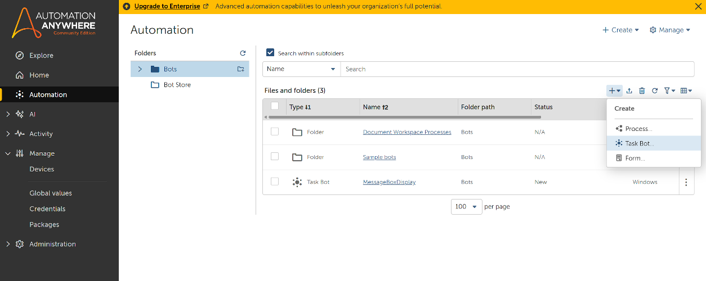

1. Click Automation in the Left Rail and click Create New Task Bot as Shown Above.
2. Enter the name of the bot and leave other options.
3. You will be re-directed to Action Panel of the Bot.

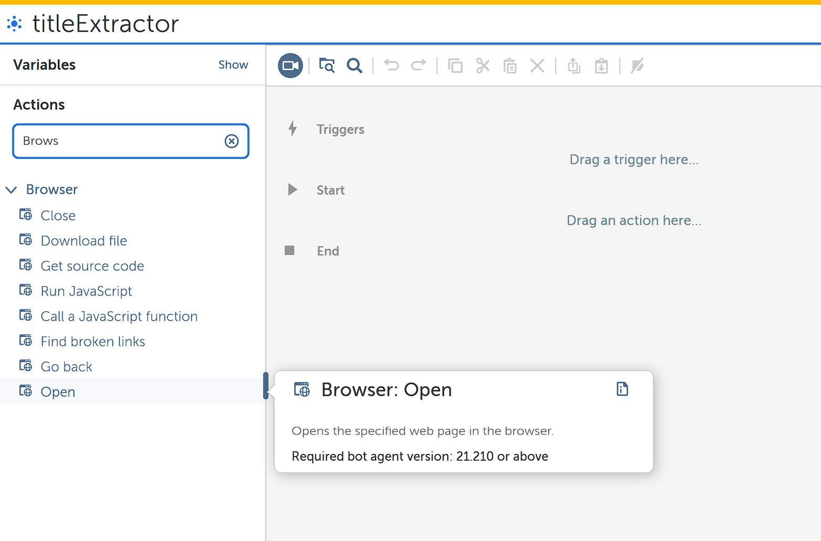

1. Add **Browser: Open** to the Action Panel from Actions in the Left rail.

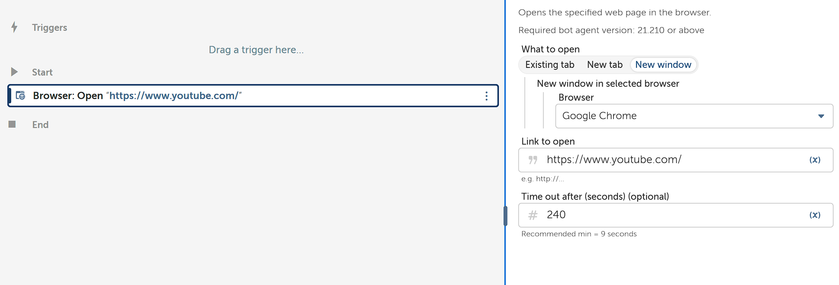

1. In Action Details of Browser: Open, add New Window and Select your Browser to open and link to open website.

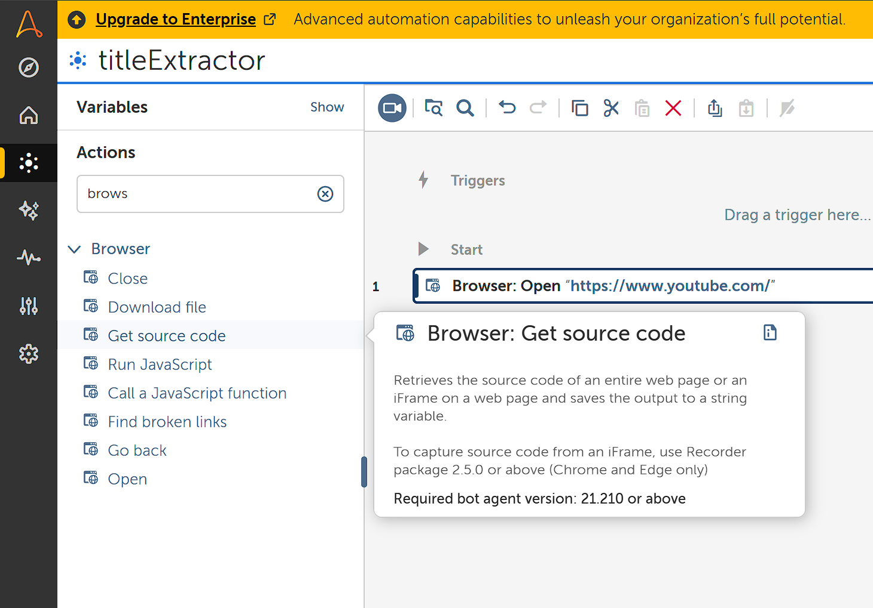

1. Add **Browser: Get Source Code** to Action Panel.

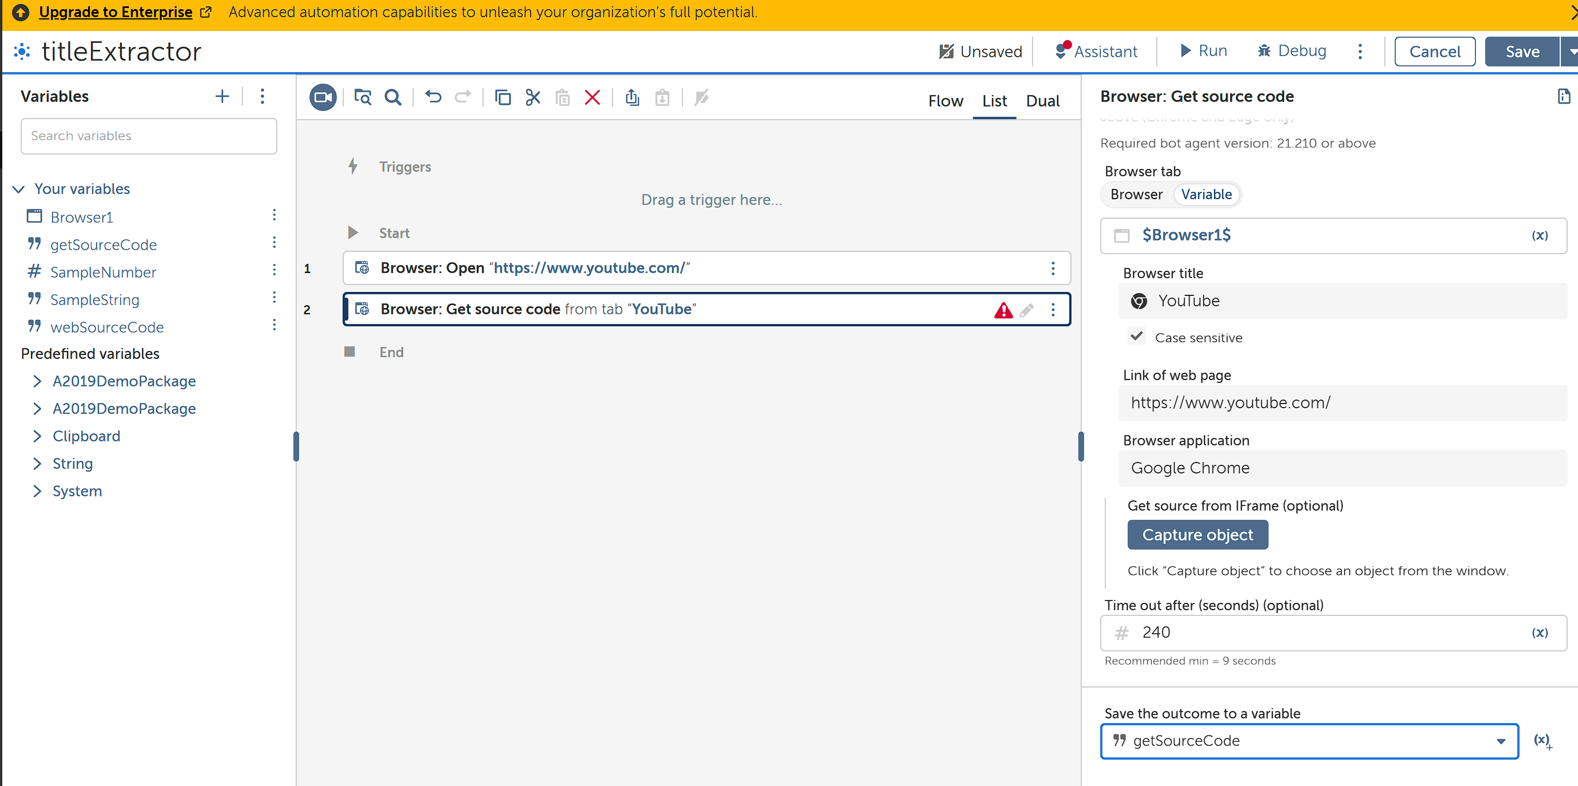

1. In Action details of Browser: Get Source Code. in browser, tab click browser and select the link(tab) to be opened (Make Sure the Tab is open). This automatically Creates a Window Variable. Create a String Variable to store the extracted Source code.

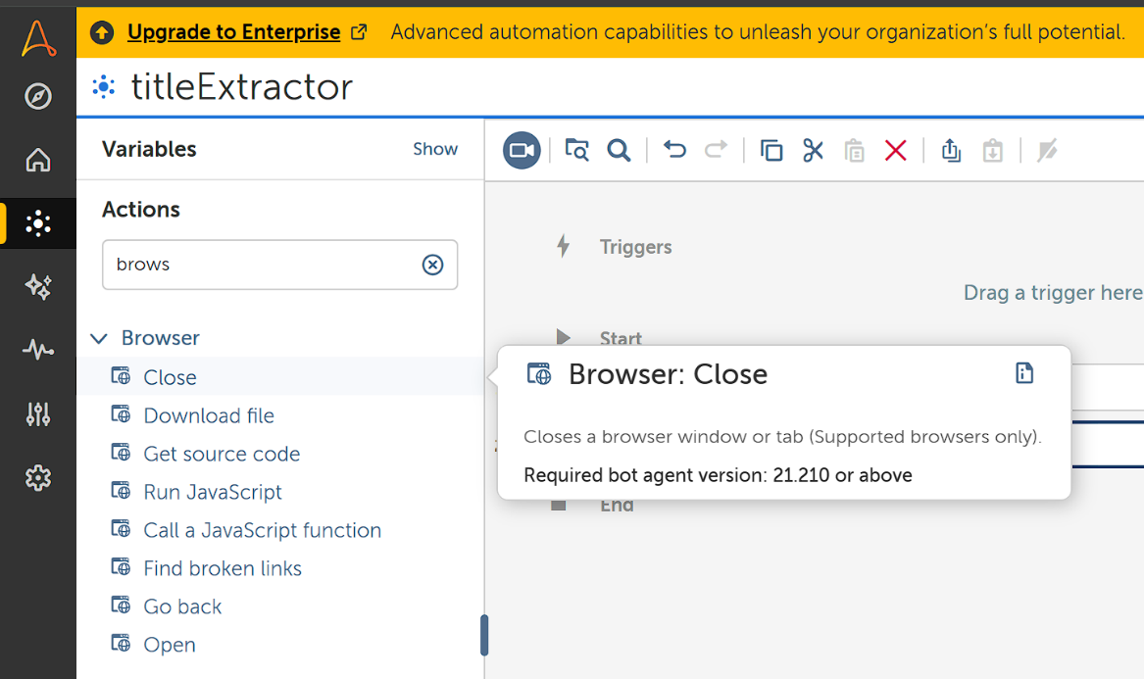

1. To close the tab, Add **Browser: Close** to Action Panel.

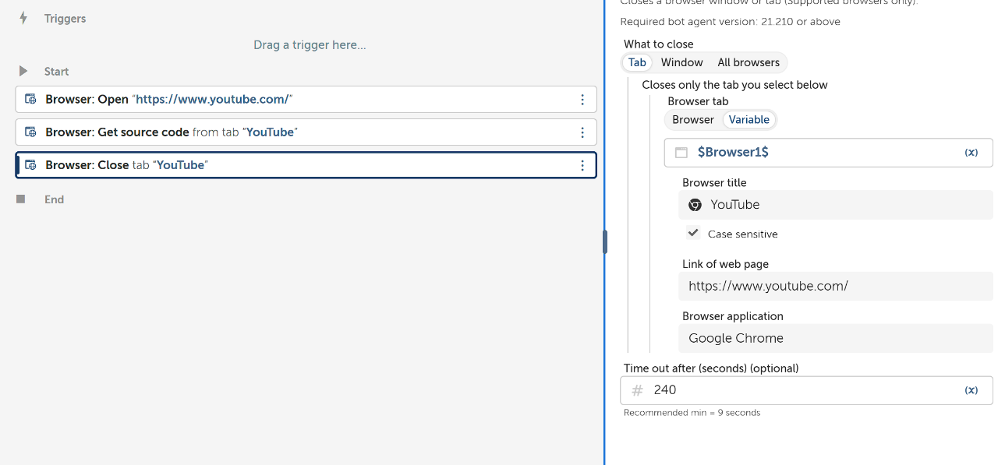

1. Add The Created Window Variable to Action details panel Where it requests a Window Variable.

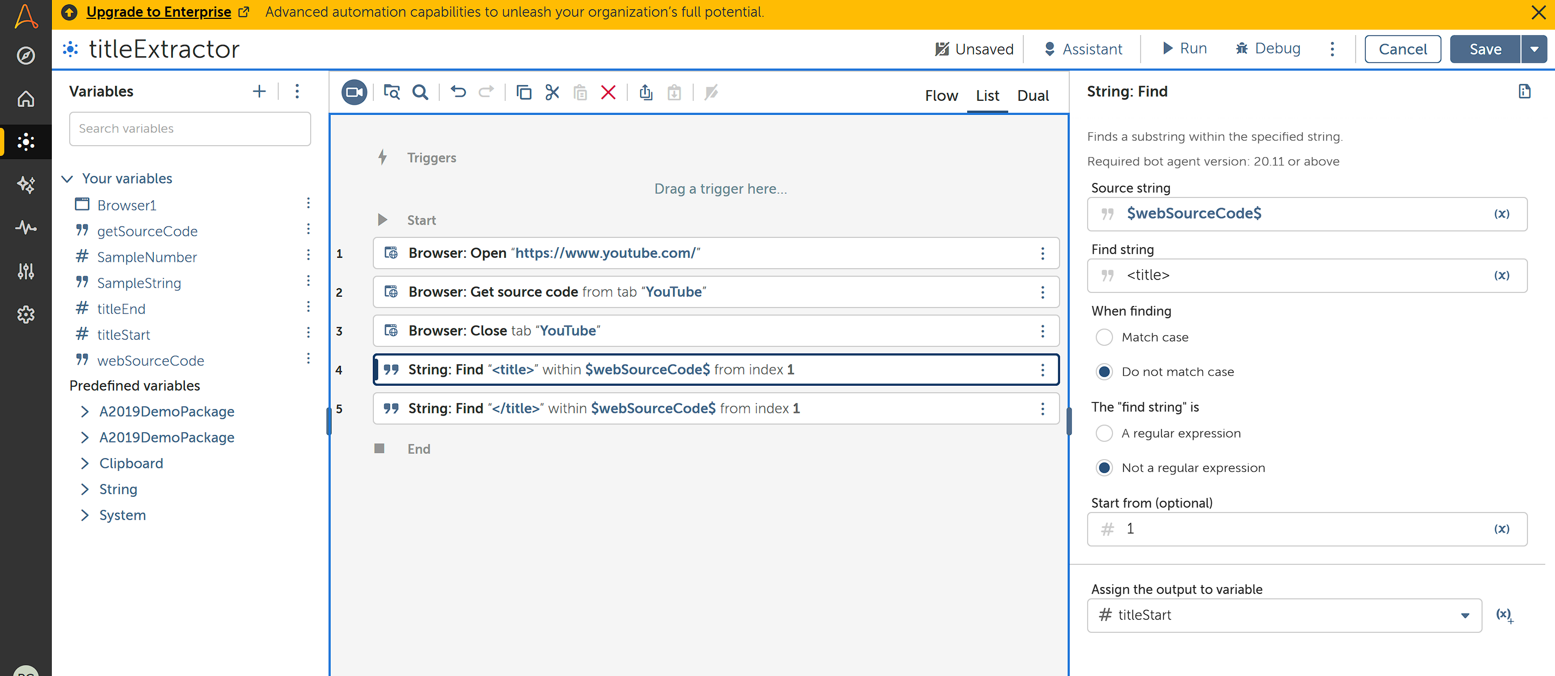

1. Create two Number variables to Store Index of <title> and </title>.

Add **String: Find** to find the index.

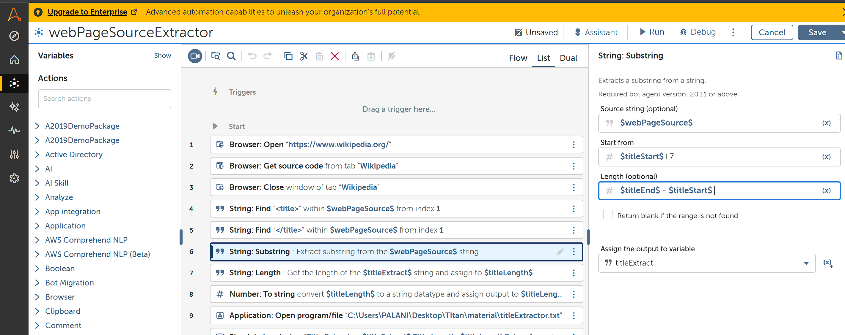

1. Add **String: Substring** to Action panel and add Start Value and Length of the String to be extracted from Start Value.

**Start from: $titleStart$ + 7. Length: $titleEnd$-$titleStart$-7.**

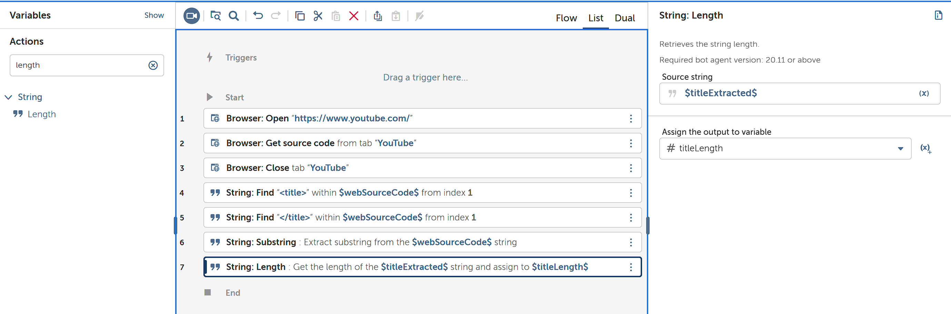

1. Add **String: Length** to Action Panel to find the String Length of title Name.

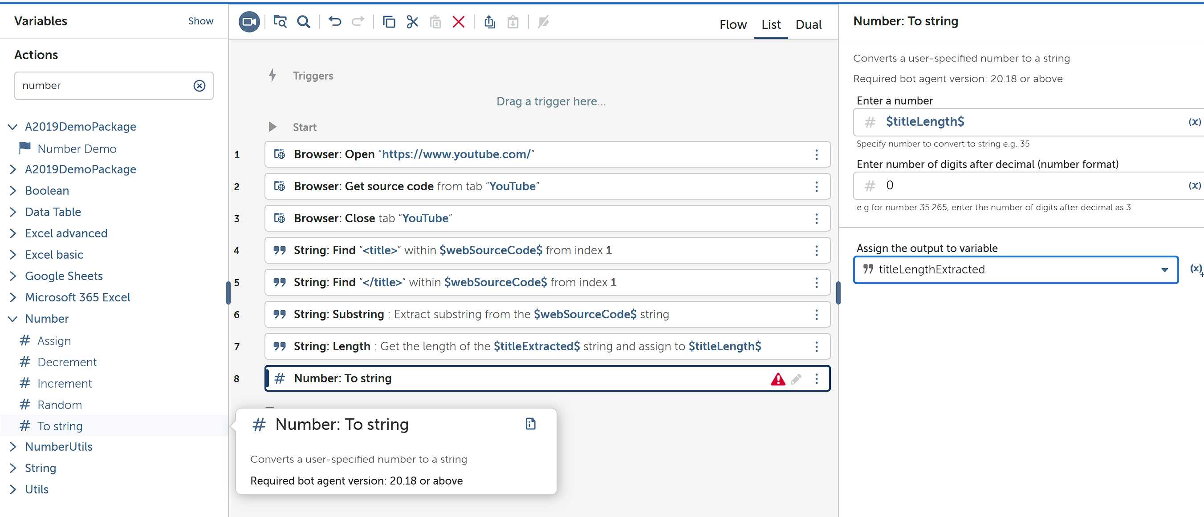

1. Add **Number: To string** to Action Panel to convert the Number variable to String Variable.

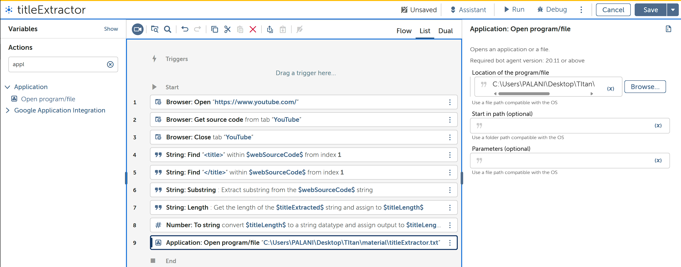

1. Add **Application: Open** to Action Panel to Open the Text file stored in the System.

Copy the path and add it.

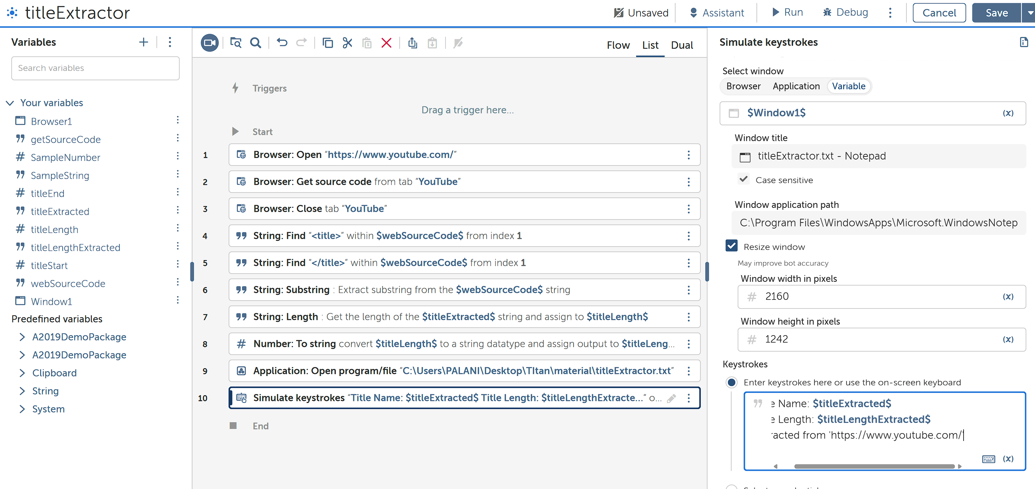

1. Add **Simulate Keystrokes** to Action Panel to Write into the text file.

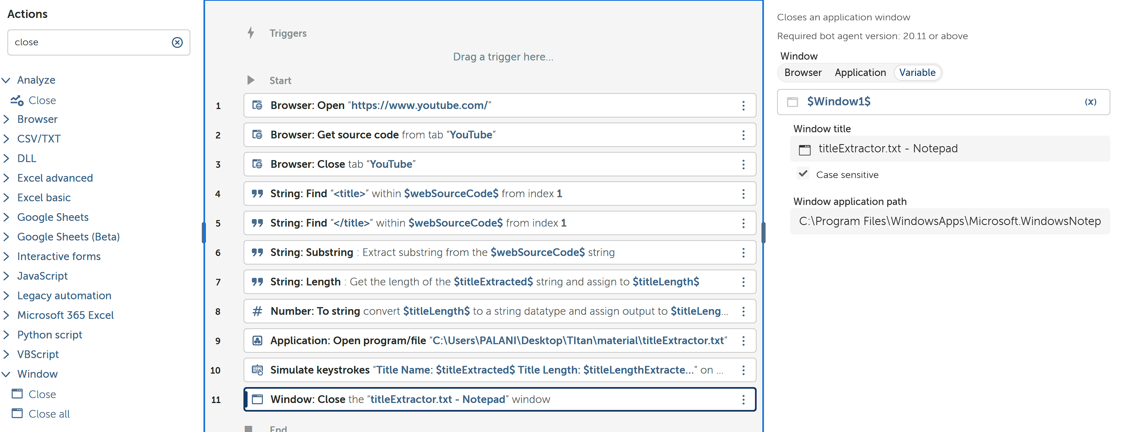

1. To close the Opened Text File, Add Action **Window: Close** and Fill it Accordingly.

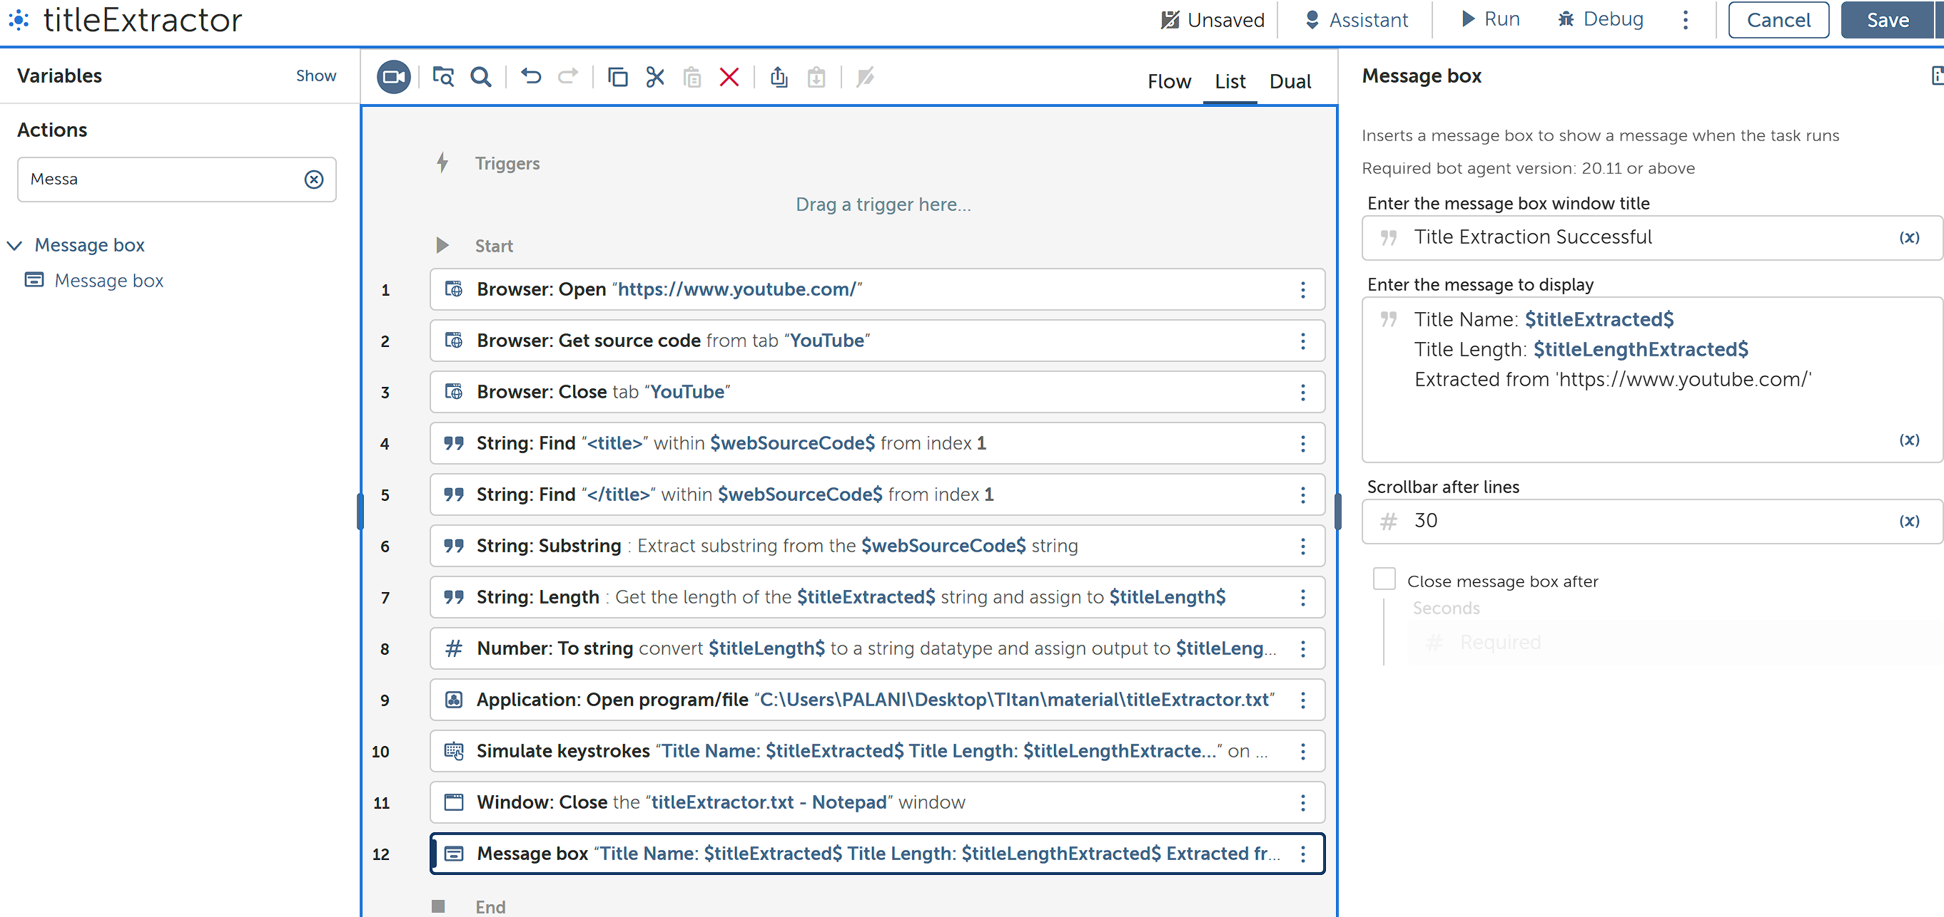

1. To display Message, Add **Message Box** to Action Panel.

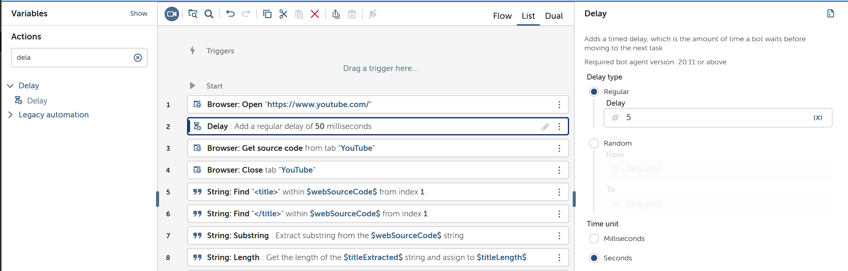

1. I have added **Delay** in between Open and Get Source Code to make sure bot retrieves the source code after the Website has Loaded Successfully.
2. Make sure you have closed the Text file, if not Bot would not Run as expected.
3. Run the Bot.